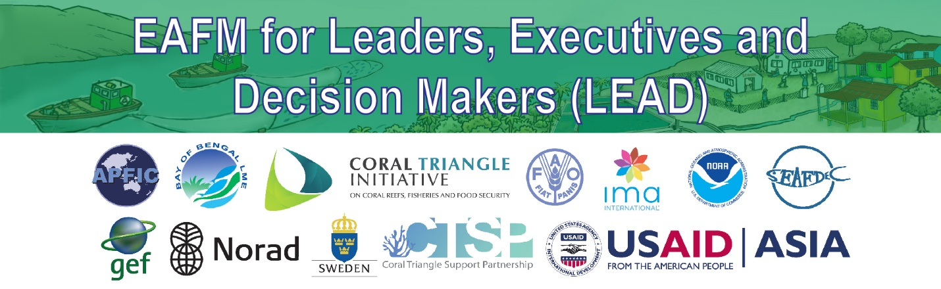

EAFM High-level Consultation for Leaders,
Executives and Decision Makers (LEAD)
1-Hour Consultation Outline
Objective: In a one-hour high-level consultation (HLC), provide opportunities for leaders, executives and decision-makers (LEADers) to understand and support the Ecosystem Approach to Fisheries Management (EAFM) to achieve sustainable fisheries through improved holistic planning and implementation.
Audience: A small number (5-8) Heads of Ministries or Deputy i.e. Minister/Secretary depending on country.

Facilitators: Minimum 1 person plus support staff (recommend including well-known/well respected master of ceremony (MC)). The facilitator must have experience and knowledge of EAFM in the nation/region, be trusted and respected by leaders, have the ability to communicate well in relevant languages (possibly supported by a translator fluent in the EAFM vocabulary), (see facilitator profile in LEAD toolbox).

Output: Report on the Consultation

One-hour LEAD Process:
Based on a “hot topic” decided before the Consultation.
The 1-hour LEAD consultation is planned to cover the following sessions and objectives:

I. Opening and Introductions
To introduce participants and facilitators, set the stage on what will be covered and how the consultation will be conducted.

II. Overview of EAFM: What why EAFM
To understand why EAFM is needed for sustainable fisheries and development and what EAFM is.

III. How EAFM can help
To examine how EAFM can help with the “hot topic”

IV. Follow-up actions
To introduce LEADers to E-EAFM training course, LEAD toolkit and eafmlearn.org and to discuss next steps after the Consultation.
V. Closing

